IW-14
YEAR 9 SCIENCE
PHYSICAL SCIENCES
LIGHT TEST

NAME: CLASS: Mark: 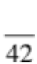

Achievement standards being tested
Energy transfer through different mediums can be explained using wave and particle models.

Mark | ND | NW | C | HC | O
Mark Range | 0-11 | 12-20 | 21-26 | 27-31 | 32-42

Multiple Choice Write the answer to each question in the appropriate box at right.

1. The electromagnetic energy we feel as heat is:

(a) infrared.
(b) ultraviolet.
(c) microwave.
(d) light.

2. The part of the eye that contains specialised cells that convert light signals into electrical signals is the:
QUESTION | ANSWER
1
2
3
4
5
6
7
8
9
10
11
12
13
14
15

(a) iris.
(b) lens.
(c) retina.
(d) optic nerve.

3. The process where the lens in the eye can change shape and allow us to focus on near and far objects is known as:

(a) the near point.
(b) the fovea.
(c) accommodation.
(d) short- and long-sightedness.

4. Refraction of light is:

(a) the wave motion of light as it passes through a substance.
(b) the bending of light as it passes from one substance into another.
(c) a reflection of light rays at the surface of a medium.
(d) the failure of light to pass through a very dense substance.

5. Light travels in lines.

(a) diagonal
(b) curved
(c) horizontal
(d) straight

Questions 6 - 8 refer to the following diagrams.

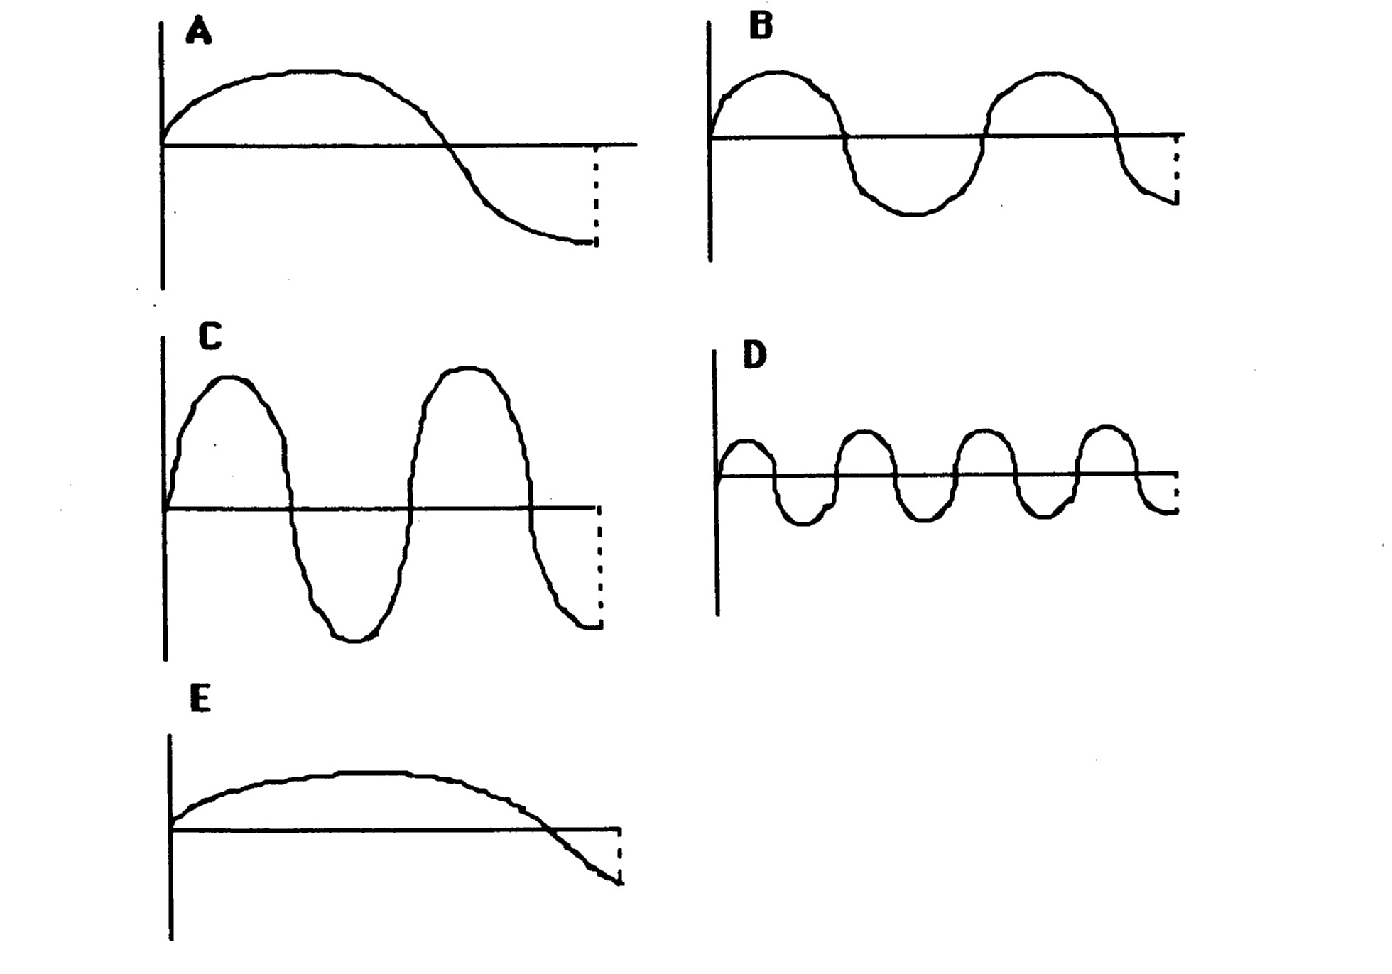

6. Which wave has the lowest frequency?

(a) A
(b) B
(c) C
(d) D
(e) E

7. The wave with the greatest wavelength is:

(a) A
(b) B
(c) C
(d) D
(e) E

8. The wave with the greatest amplitude is:

(a) A
(b) B
(c) C
(d) D
(e) E

9. The greater the curvature of a convex lens:

(a) the more it bends light and hence the shorter the focal length.
(b) the more it bends light and hence the longer the focal length.
(c) the less it bends light and hence the shorter the focal length.
(d) the less it bends light and hence the longer the focal length.

10. Mirrors will light rays.

(a) scatter
(b) refract
(c) transmit
(d) reflect

11. Compared to visible light, ultraviolet radiation has:

(a) lower frequency and higher energy.
(b) higher frequency and lower energy.
(c) higher frequency and higher energy.
(d) lower frequency and lower energy.

12. Refraction can make it difficult to judge the depth of water. How is the light shown from the point in the diagram bent?
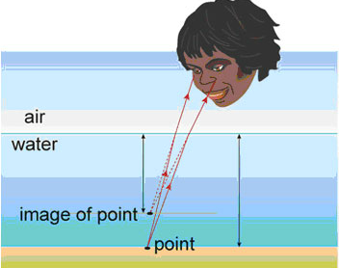

(a) Light from the point is bent towards the normal, making the point seem deeper.
(b) Light from the point is bent away from the normal, making the point seem shallower.
(c) Light from the point is bent towards the normal, making the point seem shallower.
(d) Light from the point is bent away from the normal, making the point seem deeper.

13. Which material can be classified as translucent?

(a) Red cardboard.
(b) Window glass.
(c) Frosted glass.
(d) Carpet.

14. The speed of light in air is:

(a) 300 000 000 m/sec.
(b) 300 000 m/sec.
(c) 340 m/sec.
(d) 300 km/sec.

15. Which of the following statements about light is false?

(a) Light can travel through opaque substances.
(b) Light can travel through space.
(c) The speed of travelling light can change.
(d) The density of a substance determines how light behaves when entering it.

Short Answer Write the answer to the questions in the spaces provided.

1. (a) In terms of the movement of particles, what is the difference between a transverse and a longitudinal wave? You might need to draw a simple diagram to help explain your answer.

(2)

(b) Which of these (transverse or longitudinal) describes the travel of light?

(1)

2. Draw the path of the rays in the following diagrams.

(5)
3. (a) Label the following diagram of a wave. What does each arrow represent?

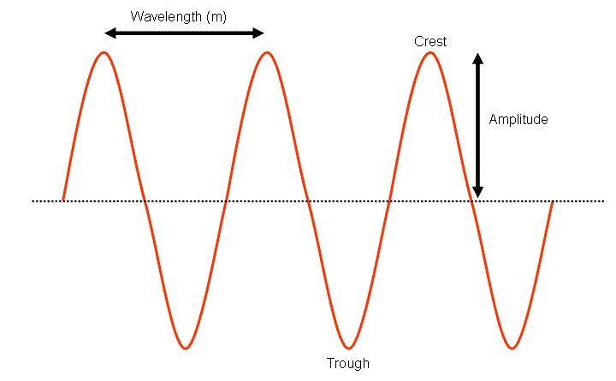
(2)

(b) Complete the diagram of the electromagnetic spectrum by naming the remaining bands.

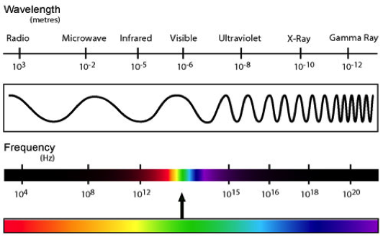

A: B:

C: D:

(4)

(c) Of the visible light spectrum, which colour of light has the lowest frequency?

(1)

(d) Of the visible light spectrum, which colour of light has the highest energy?

(1)
4. (a) Label the following illustration of the human eye.
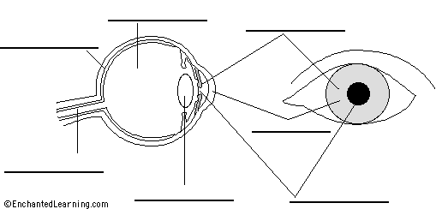
(7)
(b) Name the lens shown below. It is the kind of lens found in a magnifying glass.

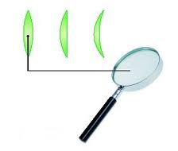

It is a lens. (1)

(c) What happens to a beam of light that passes through one of these lenses?

(1)

(d) Describe how the eye focuses light.

(2)

